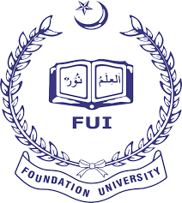
Muhammad Talha Safi Malik
Subject: Gender and Media Studies, Supervised by: Maam Fouzia Afsar
Final Project :Short Film
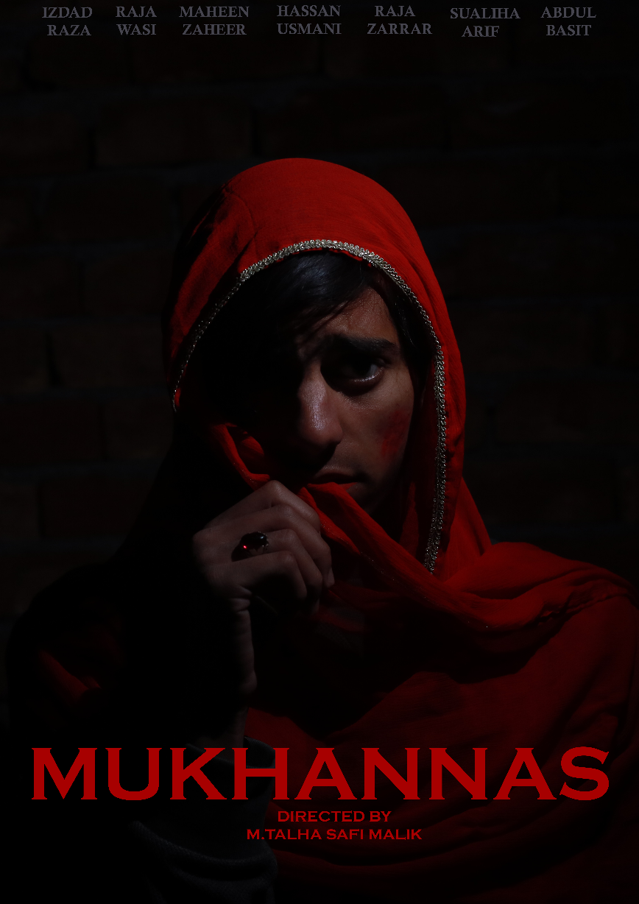
Title:
‘MUKHANNAS’ mean a third gender in a Arabic as well in Urdu.
Topic: Transgender violence in Pakistan
Transgender people, often referred to as hijras, face discrimination, harassment, and violence in various aspects of their lives, including education, employment, and healthcare. Many incidents involve physical and sexual violence, and some cases have resulted in severe injuries or even death. We choose this topic for our short film to highlight severe issues regarding third gender people in Pakistan.
Background and different aspects of violence against transgenders
Violence against transgender individuals in Pakistan is rooted in complex social, cultural, and legal factors. Here are some key aspects of the background of transgender violence in Pakistan:
- Social Stigma and Discrimination: Transgender individuals, often referred to as hijras, face deep-rooted social stigma and discrimination in Pakistani society. They are often marginalized and subjected to prejudice, harassment, and exclusion from mainstream social and economic activities.
- Cultural Attitudes: Traditional cultural attitudes and misconceptions about transgender individuals contribute to their vulnerability. In some cases, transgender people are associated with superstitions, myths, or considered to bring bad luck, leading to their social ostracization.
- Legal Recognition: While the Transgender Persons (Protection of Rights) Act was passed in 2018, recognizing the rights of transgender individuals and prohibiting discrimination, the implementation of these legal protections remains a challenge. Many transgender individuals continue to face difficulties in obtaining legal recognition of their gender identity.
- Lack of Education and Employment Opportunities: Transgender individuals often encounter barriers to education and employment opportunities, forcing many into informal and often risky occupations such as begging or sex work. This economic vulnerability exposes them to higher levels of violence and exploitation.
- Healthcare Disparities: Transgender individuals in Pakistan may experience challenges in accessing healthcare services, including gender-affirming care. Discrimination by healthcare providers can result in transgender individuals avoiding seeking medical assistance even in emergencies.
- Violence and Harassment: Physical and verbal abuse, as well as sexual violence, are pervasive issues faced by transgender individuals in Pakistan. Hate crimes targeting the transgender community, including mob violence, have been reported, leading to severe injuries and sometimes even death.
- Lack of Police Protection: Transgender individuals often encounter challenges when reporting crimes to the police. There are instances where law enforcement officials have been insensitive or unresponsive to the needs of transgender victims, further exacerbating the problem.
- Activism and Advocacy: Despite the challenges, there has been an increase in activism and advocacy for transgender rights in Pakistan. NGOs and activists are working towards raising awareness, challenging stereotypes, and advocating for the effective implementation of existing legal protections.
- Religious and Cultural Conservatism: Conservative religious and cultural norms can contribute to the marginalization of transgender individuals. Some interpretations of religious beliefs may view transgender identities as incompatible with traditional norms, leading to discrimination.
Role of media in portraying transgender violence in Pakistan
The role of media in portraying transgender violence in Pakistan is crucial in shaping public perceptions, raising awareness, and influencing societal attitudes. While media can play a positive role in advocacy and awareness, it can also perpetuate stereotypes or contribute to the marginalization of the transgender community.
Highlighting Violence and Discrimination: Media outlets can play a crucial role in highlighting cases of violence and discrimination against transgender individuals. In-depth reporting on such incidents can bring attention to the severity of the issue and prompt public discourse on the need for change.
Challenging Stereotypes: Media has the power to challenge harmful stereotypes that perpetuate discrimination against transgender individuals. By presenting diverse and positive portrayals, media can contribute to changing societal attitudes and fostering acceptance.
Platform for Transgender Voices: Media can provide a platform for transgender individuals to share their experiences and perspectives directly. This can humanize the community and empower individuals to speak out against violence and discrimination.
However, it's important to note that media can also contribute to negative stereotypes, sensationalism, or perpetuate biases. Journalistic ethics, responsible reporting practices, and awareness of the potential impact on vulnerable communities are essential to avoid reinforcing harmful narratives.

Gaps regarding the issue of Transgender violence
Several gaps and challenges persist in addressing transgender violence in Pakistan. These gaps span various aspects. Some of the key gaps include:
Inadequate Legal Protections: While the Transgender Persons (Protection of Rights) Act was a significant step forward, the effective implementation of these legal protections remains a challenge. Gaps in enforcement, awareness, and accessibility can limit the impact of existing laws.
Social Stigma and Discrimination: Deep-rooted social stigma and discrimination persist, leading to the marginalization of transgender individuals. There is a need for comprehensive awareness campaigns to challenge stereotypes, promote acceptance, and foster inclusivity within society.
Violence Reporting and Police Response: Many transgender individuals hesitate to report incidents of violence due to fear of further discrimination or insensitivity from law enforcement. Ensuring that the police are trained to handle cases involving transgender victims sensitively and effectively is crucial to closing this gap.
Economic Insecurity: Limited access to education and employment opportunities for transgender individuals contributes to economic insecurity. There is a need for initiatives that address economic disparities and promote equal opportunities in education and the workforce.
Lack of Transgender Representation: The media often lacks diverse and positive portrayals of transgender individuals. Increased representation in media, including news, entertainment, and advertising, can help challenge stereotypes and promote a more inclusive narrative.
Educational Barriers: Discrimination and bullying in educational institutions can hinder the academic progress of transgender students. Inclusive educational policies, awareness programs, and anti-bullying measures are needed to create safe learning environments.
Family Rejection: Many transgender individuals face rejection and discrimination within their own families, leading to homelessness and further vulnerability. Initiatives that promote family acceptance, counseling services, and support networks can address this gap.
Addressing these gaps requires a coordinated effort involving government bodies, NGOs, the media, healthcare providers, educational institutions, and the broader society. Advocacy, awareness campaigns, and policy reforms are essential components of creating a more inclusive and supportive environment for transgender individuals in Pakistan.

Summary of short film Mukhannas
This film is about a transgender live in a old Rawalpindi area. Name Atif Tabassum everyone except his/her mother hates and dislike him/her people of society see him/her as a “chakka” a term use for third gender in a negative way. His/her brother doesn’t like his/her appearance and wanted to get rid from him/her. Because of criticism face by society family members saw him/her as a disgrace to their honor. They always wanted to dressed him/her in a boys getup one day his/her brother saw him/her in a feminine dressing and start beating and abusing him/her . He/she face domestic violence on daily basis and to get rid from this lifestyle he/she decided to run from the home at night. Unfortunately, neighborhood villainous boys saw him/her and start following him/her and then start harassing and raped him/her. As in Our society 3rd Genders are use for gratification of sexual desires. After this calamity he/her ran back to home for the sake of safety but his/her brother saw him/her coming back to home in notorious condition. When he/she confirmed him about rape he killed him/her on the basis of honor. We can say honor killing mother rush to stop his younger son but failed and he/she died. His family called the police and Atif Tabassum case got hype and after pressure from social media and NGOs court announced death sentence to the criminals.
Characters in this short film
Atif Tabassum the Transgender
Qaiser Tabassum the Brother
Shaista Tabassum the Mother
Mehr Tabassum the Sister
Billu and Shani the Rapists
Ghulam Mustafa Hashmi the Investigating Officer
Faraz Ali and Riaz were the Police constables
Syeda Najaf Zahra TV Anchor
Cast and Crew in this Short Film
Director: M.Talha Safi Malik
Producer: Hassan Akhlaq Usmani
Writer: M.Talha Safi Malik
Assistant Director: Maheen Zaheer
Graphic Designer: Raja Wassi Abbass
Editor: Raja Zarrar Iqbal
Video Production: Hassan Akhlaq Usmani, Abdul Basit, Raja Khudadad Mubarak
Audio and Effects: Bilal Ahmed Usmani
Cast
- Izdad Raza
- Maheen Zaheer
- Raja Wassi Abbas
- Sualiha Arif
- M.Talha Safi Malik
- Abdul Basit
- Bilal Usmani
- Syed Sheraz Bukhari
- Abdul Wahab
- Syeda Najaf Zahra
- Ali Hassan

The main Message to convey
The story depicted in this films underscore the urgent need for increased awareness, empathy, and action to address the issues faced by the transgender community in Pakistan. As we engage with this powerful medium of storytelling, it is my hope that these narratives will serve as a catalyst for change. Let us join hands in spreading awareness about transgender violence and advocating for a more inclusive and accepting society. By fostering open conversations, challenging stereotypes, and supporting initiatives that promote equal rights and protections, we can contribute to positive change. To promote gender education through media as in academic there is not any single course in Pakistan School and college level education which can provide awareness in society regarding these issues. I myself also feel that in our Gender subjects at Bachelors level we even not taught regarding the violence against transgender and what are the transgender’s rights
We encourage you to share these films and engage in discussions with friends, family, and colleagues. Together, we can help create an environment where every individual, regardless of their gender identity, can live free from fear and violence.

